EVENT CLOSURE TABLE
Event
(What Happened)
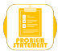
Problem Statement
(Potential effects/risks)
Containment Action(s) |  | Notes: | Stakeholder/  Action Owner | Due Date | Actioned | Additional detail:
1
2
3
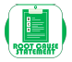
Root Cause Statement
Corrective Action(s) |  | Notes: | Stakeholder/  Action Owner | Due Date | Actioned | Additional detail:
1
2
3
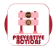
Preventive Action(s) |  | Notes: | Stakeholder/  Action Owner | Due Date | Actioned | Additional detail:
1
2
3

Validation / timescale

